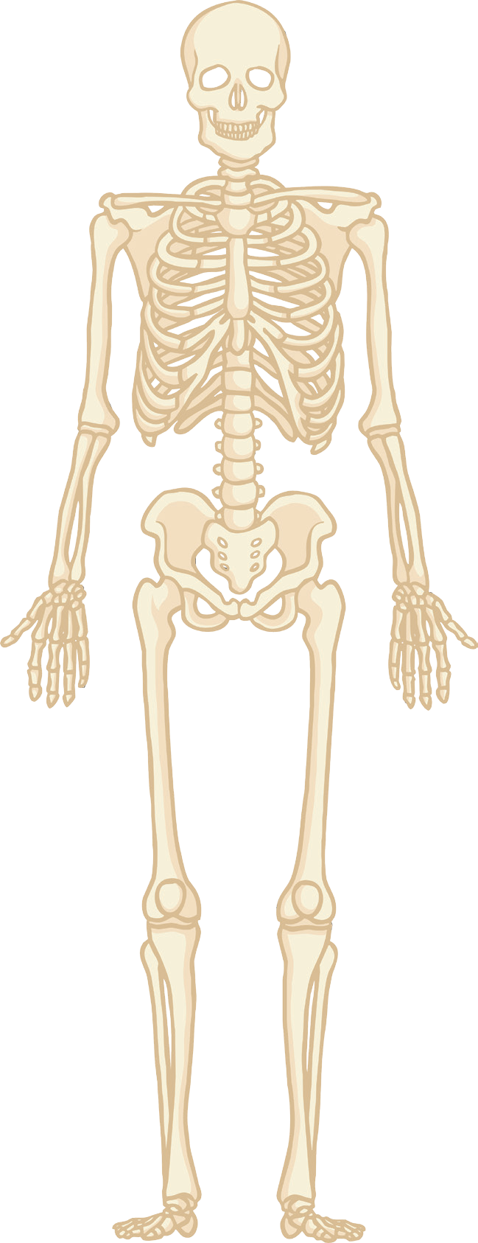True or False Structure and Function of the Skeletal System
1 Support is one function of the human skeleton.
Adduction is a movement towards the body.
The femur is located in the lower arm.
The elbow is an example of a ball and socket joint.
A tendon connects muscle to bone.
Flexion is increasing the angle at the joint.
The articulating bones of the knee joint are the femur, tibia and fibula.
The role of cartilage is to absorb shock and reduce friction in the joint.

2
3
4
5
6
7
8

The cranium protects the heart.
9
10

Blood production and mineral storage are functions of the skeleton.

Extension
True or False Structure and Function of the Skeletal System

Can you make up five true or false questions on the structure and function of the skeletal system.

1

2

3

4

5

